**Digital Marketing Plan for Branding/Promotion**

**We will take care below points for the Internet Marketing:**

1. **Blog Marketing: Blog Marketing is must for brand awareness.**

**IMAGE**

## **The Pros of Blog Marketing:**

* **Easy to use**
* **Build website traffic**
* **Improves search engine ranking**
* **Engages Your Market**
* **Creates More Opportunities for Revenue**

1. **Content Marketing:**

**Content marketing also plays vital role in the brand awareness. The tone of content is very important it reflects the personality of your brand**

1. **Website Blogs: website blog is another better option for branding. This is because a business blog can help achieve a number of goals, such as increasing the exposure of your brand and building your brand authority, which will make it easier for visitors to trust your brand.**
2. **Engage with your customer/visitors:**

**You need to engage with your visitors if they are going to connect with your brand. Without any kind of engagement, your brand identity isn't going to be as strong. Allow your readers to leave comments on your blog posts and encourage them to do so.**

1. **Link to high Authority websites:**

**Linking to high-authority websites via your blog content does a number of things. First of all, the sites you link to may link back to you in return, thereby helping to boost your search rankings (external links are a big factor in determining rankings).**

1. **Reply to Comments:** **blogs are social, so people will ask questions, provide feedback, or share their opinion. We should always Delete spam posts.**
2. **Cross promote to other popular news websites: Sharing your articles on places like Reddit, Digg, Delicious and Quora can help your brand attract a whole new audience. Your content can be viewed by thousands of visitors each day that you can interact with and bring to your website and other social networks.**
3. **Re-share existing blog content:** **If you have received a favorable response on a particular article then schedule this several times throughout the year to continuously share on social media. Additionally you can add updated information and graphics and create a newer version for your own blog or on other publishing platforms like Medium and LinkedIn.**

**PRROPOSAL FOR SEO/SMO/PPC**

**Search Engine Optimization:**

**We have conducted an SEO audit for your website and below are the observations from the same. These are the points where we are weakening in terms of SEO.**

1. **Website:** <https://diazforsheriff.com/>

**Dated: 28/02/2020**

* **Site Audit**
* **Content Audit**
* **Competitor Analysis**

**Below are the points which we have observed we need to fix.**

* **PAGE ANALYSIS:**

1. **Title: your website Title is not optimal.** **The most effective page titles are about 10-70 characters long, including spaces.**
2. **Meta Description: Meta Description is not structured properly, it is very high and has keyword stuffing because of which your ranking gets affected and Google penalize you,** [**Meta descriptions**](http://en.wikipedia.org/wiki/Meta_element#The_description_attribute)**are useful because they often dictate how your pages are shown in search results. For optimum effectiveness will keep it 160-300 characters.**
3. **Content Ratio: We would suggest more content on your website as Google loves good quality content page, as content is king.**
4. **Heading Tags: We suggest implementing Heading Tags. To get more impactful we can add keywords in heading Tags.** **HTML Tags are not properly set on the website, major and important keywords are not marked properly throughout the website**
5. **Micro formats: This page does not utilize Micro format markup.** [**Micro format**](http://en.wikipedia.org/wiki/Microformat)**is a markup that is used to structure the data that is being sent to search engines more effectively. Will validate your markup with the**[**Google Structured Data Testing Tool**](https://search.google.com/structured-data/testing-tool/#url=https%3A%2F%2Fzeencollagen.com%2Fen%2Fzeen-products%2F)**.**
6. **Image Alt TAGS: we have found some pages missing ALT attributes.as we all know Google does not read any image so we put any alternative text to recognize the images.** **Images do not have the ALT Tag which means that the search engine crawlers are not able to identify your images**
7. **Favicon:** **No Favicon present, this is something that helps in increasing brand awareness.**
8. **Google Analytics: Google Analytics not integrated; you will not be able to judge from where you are receiving the traffic.**
9. **Schema.org:  Your page does not utilize**[**Schema.org**](http://schema.org/)**markup.** **Using markup data on your webpages is a powerful way to increase your visibility to search engines and gain higher click-through rates, which may in turn lead to better rankings.**

* **Mobile Compliance:**

1. **AMP: we observed your website’s page does not have an AMP version. We should creating Accelerated Mobile Pages, which is an easy way to make your pages load instantly on any mobile device.**

**Though AMP is not a ranking factor. AMP does affect clicks, impressions and user experience, which in turn affects SEO.**

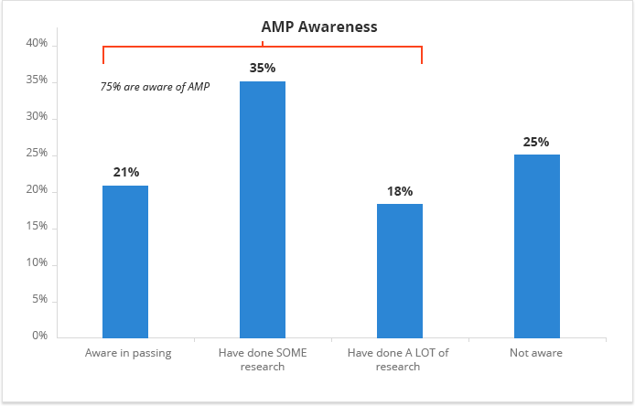

* **Google Search Console: This tool plays vital role between client and Google.by this tool we can analysis the crawl, index and serving information of you page .any unwanted link we can disavow by this.**

• **Backlink Analysis (**<https://diazforsheriff.com/>**):**

**We have observed below points:**

**There are only 5 Backlinks in the website. Which can be weaken website SEO later on because Google give more credit to that have more good quality backlinks.so we will create the good quality backlink through many activities ,which we have covered in below section:**

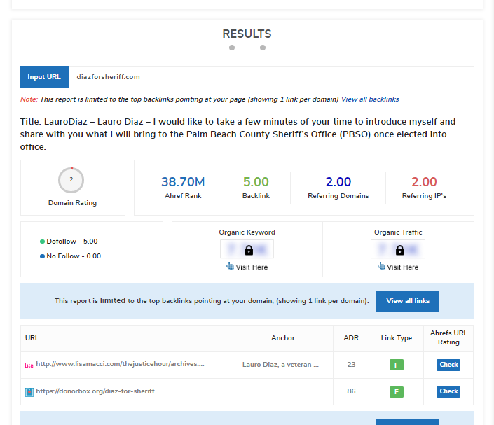

1. **Referring Domains: Only 2 referring domain found, need to create more by doing some off page activities on daily basis mentioned above.**
2. **Referring IP’s:2**
3. **Do follow Links: 5**
4. **No follow link: 0**

**Our Strategy would be when building backlinks not focus only on the quantity of links instead go for quality and relevance link too.**

**We will target that website for link building that has good page authority and domain authority.**

* **Link Building**

**To get more and good quality backlinks we will be doing below activities on daily basis:**

1. **Bookmarking**
2. **Blog Submission**
3. **Classified submission**
4. **Article submission**
5. **Image and PPT submission**
6. **Web2.0**
7. **Press Release submission**
8. **Info graphic creation and submission**
9. **Forum Submission**
10. **Directory submission**

* **Keyword Analysis:**

#### **Keywords Consistency: we have found page’s main keywords are not distributed well across the important HTML tags.**

**Our strategy would be like page content must be focused around those keywords we would like to rank for and also distributed across such as title, Meta tags and Header tags.**

1. **Performance Results: Your page performance needs improvement**

**Website Performance can indirectly affect search engine ranking. Below are the factors where we need to focus**

* **Page size information:** **Your page's file size is quite large which, regardless of other optimizations, can reduce load speed and impact user experience. A general rule is to keep your page under 5MB in total file size.**

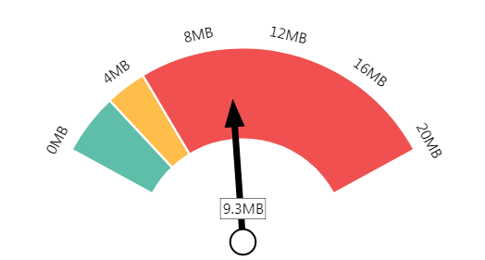 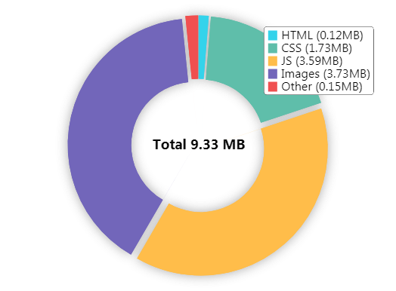

* **Deprecated HTML**

**Inline CSS: Inline styles are an older coding practice and discouraged in favor of using CSS style sheets, due to their ability to degrade page load performance and unnecessarily complicate HTML Code.**

**6. Performance Results: Your page performance needs improvement**

**Website Performance can indirectly affect search engine ranking. Below are the factors where we need to focus**

* **Competitor Analysis:**

1. **Competitors Backlink audit: This is very important and crucial part of SEO. We should always analyze the link profile of competitors and look for opportunities that can improve link building and search performance.**

**We will be checking all the competitors’ backlink (inbound link) that are pointing to top ranking pages, so we won’t miss out any important link opportunities.**

1. **Competitor’s keywords: we need to put some more keywords by which competitors rank for.so In future we will be on top by many keywords and our competitors will not beat us.**

**Social Media Optimization:**

**SMO: For brand promotion: Can get maximum Benefits by doing following activities on daily basis.**

**Daily Activities:**

|  |  |  |
| --- | --- | --- |
| 1. **Facebook**      1. **LinkedIn**      1. **Twitter** 2. **Instagram** 3. **Pinterest** | * **Post on daily Basis** * **Video Promotion on Facebook** * **Blogs** * **Post Banner related to Business** * **Daily Post** * **Articles** * **Banners** * **Company Page creation** * **Daily Tweets** * **Daily post activity where you can increase followers** * **Daily post activities with hash tags** * **Daily post activities on pinterest** |  |

**Google Ad words Proposal**

**(Pay per Click)**

**We need to use all the PPC food groups in a right way, with the right portion then we’ll be able to get the highest ROI possible:**

**Show your ads more often to people searching for what your business offers**

**We offer maximum clicks, impression and CTR with minimum budget**

**Below are the activities which we will do on daily basis.**

**PPC PROPOSAL: Daily Action**

**Total campaign –5**

**Keywords Analysis – 20 keywords for each campaign**

**Total 5 = 20*5= 100 keywords analysis for the campaign**

**Steps for the Google ad words (PPC)**

1. **Goal of the Campaign**

* **Traffic**
* **Leads**
* **Calls**

1. **Campaign creation**

* **Search Campaign**
* **Smart campaign**

1. **Competitor’s Analysis**
2. **Keywords Research Analysis**

**Keywords Analysis Points to keep in mind while running the Google Ads.**

* **Average Monthly searches**
* **Competition**
* **Suggested bid**
* **Quality score**

1. **Structure and organize your PPC keywords**
2. **Include negative keywords in your campaign**
3. **Campaign page creation**

**Number of projects –5**

1. **Landing page creation**
2. **Write better Ad copy creation**

* **Better ad creation: we will crafts some killer ads so it will make all the difference in terms of ROI.**

1. **There are number of extension we can feature in ads. Extensions make more visible your ads in SERPs.**

* **Site Extension**
* **Call extension**
* **Location extension**
* **App extension**
* **Review extension**
* **Callout extension**
* **Structured snippet extension**

1. **Competitor’s bidding Analysis**

**Keep an eye to competitors biding and their ads positions in SERPs. On daily basis so accordingly we can keep changing our strategy to come out first positions.**

1. **Set audience**

* **Age**
* **Gender**
* **Audience exclusion (can exclude the Audience)**

1. **Ad schedule**
2. **Ads Optimization score**

* **Analysis of ads optimization score is very important factor. We need to maintain the score on daily basis.**

1. **Locations to be targeted**
2. **Budget per Month**
3. **Bid strategy**

* **Estimated first page bid**
* **Estimated first position bid**

1. **Device setting**

**You can set the device option where you want your ads should be shown.**

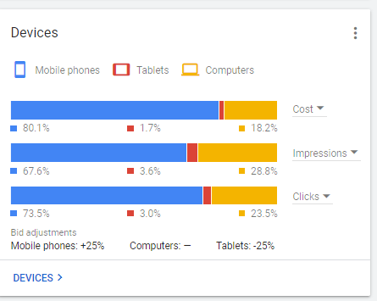

1. **Auction Insights**

**In auction insights we can check your ads frequency (impressions) in SERPs among your competitor’s.**

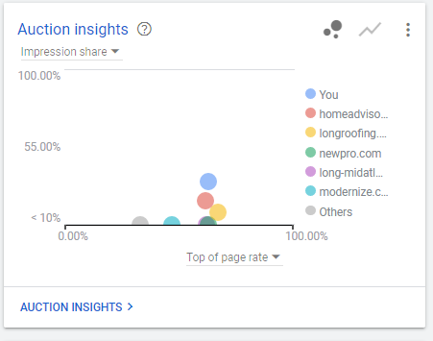

1. **Monitoring clicks and impression on daily basis to keep improving your campaign.**

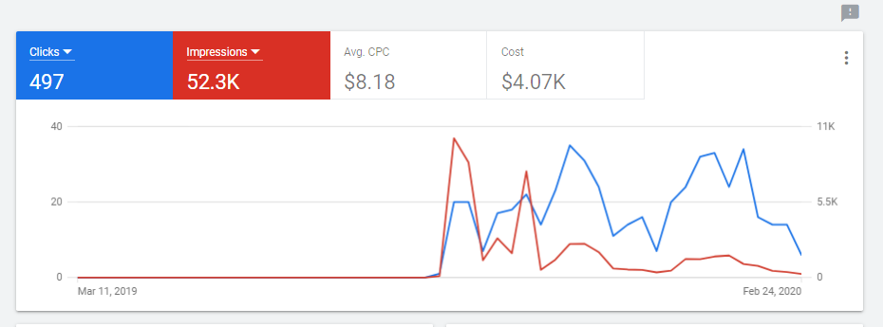

**Payment Option:**

**Two modes are available for the payment**

* **Manual Payment**
* **Automatic Payment**

**For Detailing about the Payment method kindly go through below link.**

<https://support.google.com/google-ads/answer/1704418?hl=en&ref_topic=3119102>

**Billing Information:**

**We will send you the link after creating your Google account for the payment option .after clicking the link you can directly pay to Google by using your account/card details. You can choose any mode for the payment.**

**Or else with your permission we can also make the payment by using our details after that we will share you the receipt provided by the Google. That payment mode will be totally transparent.**

**------------------------------------------------- End of Document----------------------------------------------------**